Contents
Responsible AI with GitHub – Module 1 3
Microsoft and GitHub's six principles of responsible AI 3
Introduction to GitHub Copilot – Module 2 4
GitHub Copilot, your AI pair programmer 4
GitHub Copilot features 4
Subscription plans 6
Interact with Copilot 8
Set up, configure, and troubleshoot GitHub Copilot 12
Sign up for GitHub Copilot 12
Enable or disable GitHub Copilot in VS Code 12
Prompt engineering foundations and best practices 12
Principles of prompt engineering 12
How Copilot learns from your prompts 13
GitHub Copilot user prompt process flow 15
GitHub Copilot data 17
Prompt types supported by GitHub Copilot Chat 18
GitHub Copilot Large Language Models (LLMs) 19
GitHub Spaces 20
Creating Space 21
Visibility and sharing 22
Security & Access 22
Versioning and freshness 22
Governance 22
Checklist for creating space 22
Do's and Don'ts of Working in a Space 24
Exercise - Democratize tribal knowledge using Copilot Spaces 24
Advanced GitHub Copilot features 26
Code completion with GitHub Copilot 28
Types of comments utilized 29
Comment-driven code generation 30
GitHub Copilot Chat 32
How to improve GitHub Copilot Chat responses 32
Model selection and premium features 35
Copilot Agents 35
GitHub Copilot on GitHub.com 36
Accessing Copilot on GitHub.com 36
GitHub Copilot Agent tasks on GitHub.com 36
GitHub Copilot for the Command Line 39
Installing and launching Copilot CLI 39
Sandboxed execution environments 40
Local sandboxing 40
Cloud sandboxing 41
GitHub Copilot App 43
How the GitHub Copilot app works 45
GitHub Copilot plans – Management and Customization 47
Management policy features 47
Customization features 48
Contractual protections in GitHub Copilot and disabling matching public code 49
Manage content exclusions 50
Impact of content exclusion on code suggestions 50
Limitations of content exclusions 51
Troubleshoot common problems with GitHub Copilot 52
Use cases for AI with GitHub Copilot 53
Boost developer productivity with AI 53
Areas where GitHub Copilot proves particularly beneficial 53
Accelerating pull request workflows 54
Orchestrated AI workflows 55
AI in the Software Development Lifecycle (SDLC) 57
Limitation and Impacts of GitHub Copilot 58
Measure productivity gains 59
Implementing a measurement framework 59

Responsible AI with GitHub – Module 1

Microsoft and GitHub's six principles of responsible AI

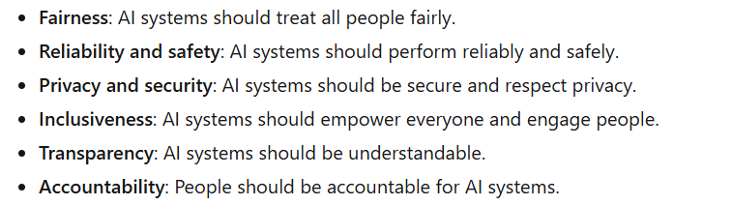

Introduction to GitHub Copilot – Module 2

GitHub Copilot, your AI pair programmer
GitHub Copilot is a service that provides you with an AI pair programmer that works with all of the popular programming languages.
- 46% of new code now written by AI
- 55% faster overall developer productivity
- 74% of developers feeling more focused on satisfying work

Microsoft developed GitHub Copilot in collaboration with OpenAI. GitHub Copilot is powered by the OpenAI Codex system.
GitHub Copilot is available as an extension for VS Code, Visual Studio, Vim/Neovim, and the JetBrains suite of IDEs.

GitHub Copilot features
Copilot chat
GitHub Copilot includes an interactive chat experience directly inside supported editors (like Visual Studio Code, Visual Studio, and others). With chat, you can:
- Ask questions about your code
- Get explanations of logic or errors
- Generate tests or documentation
- Explore how to implement new features

Copilot pull request summaries
When we open a pull request, Copilot can automatically generate a summary description of the changes. This helps reviewers understand intent, reduces the work in writing PR text, and improves clarity in collaboration.
Copilot code review assistance
Copilot can assist in code review workflows by suggesting potential issues to look at, describing changes, pointing out edge cases, and proposing improvements for reviewers. This helps speed up review cycles and reduce manual overhead
Copilot for the CLI
The GitHub Copilot command-line interface (CLI) allow you:
- ask for command suggestions, code snippets
- generate shell scripts
- understand output or errors
- generate and improve projects from the CLI
Copilot Spaces
Copilot Spaces provide a dedicated place to collaborate with AI on a project. In Spaces, you can:
- explore project structure
- ask high-level planning questions
- refine requirements
- iterate on designs
Spaces offer a context-rich environment where Copilot retains knowledge of your repository and workflow
Copilot Space → a project room where you bring that repo, plus:
- requirements
- design docs
- notes
- diagrams
- instructions for Copilot
- conversations
- planning context
Copilot Cloud Agent
The Copilot Cloud Agent acts as an autonomous AI assistant. It performs multi-step coding tasks based on your instructions. You can ask it to:
- Generate multiple related files
- Implement a feature set
- Build scaffolding from a specification
Copilot executes these tasks under your direction, helping you complete complex workflows faster and stay in the flow.

Subscription plans
GitHub Copilot is available in several plans, each offering different capabilities for individuals, teams, and organizations
Refer to the official documentation for the most up-to-date information.
https://docs.github.com/en/copilot/get-started/plans
1.GitHub Copilot Free
GitHub Copilot Free allows individual developers to use GitHub Copilot at no cost
- Code completions in supported editors
- Limited monthly completions and chat requests
- Access to advanced AI models
2.GitHub Copilot Pro
GitHub Copilot Pro is designed for individual developers who want enhanced capabilities beyond the Free plan.
Key features:
- Higher usage limits compared to the Free plan
- Priority access to the latest AI models
- Advanced code suggestions and explanations
- Integration with supported IDEs (VS Code, Visual Studio, JetBrains, Neovim)
- Automated test generation and code explanation feature

3.GitHub Copilot Pro+
Copilot Pro+ includes all the features of Copilot Pro with additional access to premium model usage and priority performance on high-demand resources. It's suited for individuals with higher usage needs.
Key features:
- All Pro features
- Additional premium request capacity
- Priority infrastructure access - It means your requests get processed ahead of regular users when Microsoft’s AI systems are busy.

4.GitHub Copilot Business
GitHub Copilot Business is for organizations that want to manage Copilot access and benefit from additional security and compliance features.
Key features:
- Centralized management and policy controls
- Security vulnerability filtering
- Code referencing and public code filtering
- IP indemnity and enterprise-grade security, safety, and privacy
- Chat in IDE and mobile
- Filter for public code

5.GitHub Copilot Enterprise
GitHub Copilot Enterprise is designed for large organizations and enterprises that require advanced capabilities, deeper integration, and enhanced personalization.
Key features:
- All Business features
- Personalized code suggestions based on internal/private code
- Integration with GitHub Enterprise Cloud
  - Copilot can:
    - read your company’s private repos
    - generate code based on your internal codebase
    - follow your organization’s coding patterns
    - help with PRs, issues, documentation
    - All while respecting enterprise access controls
- AI-powered search and documentation generation across your codebase
- Enhanced pull request support with AI-powered tags and summaries
- Organization-wide customization and fine-tuning of Copilot models
- Deep integration with GitHub for chat and codebase exploration.

GitHub Copilot Enterprise includes everything in GitHub Copilot Business, plus a layer of personalization for organizations.

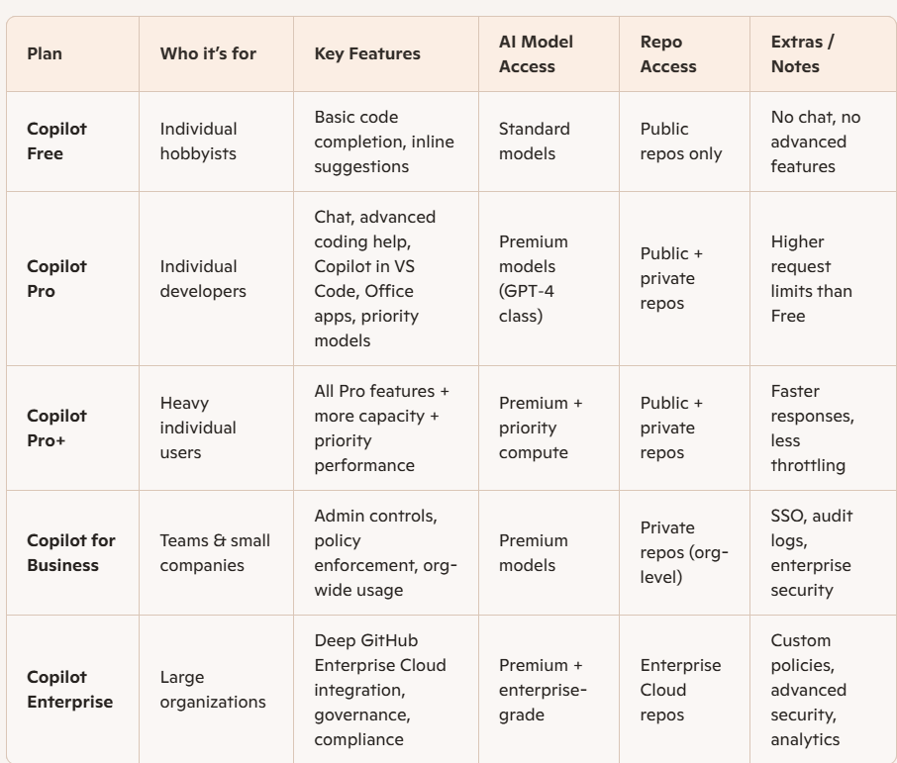

Interact with Copilot
The following sections describe the various ways to trigger and use GitHub Copilot
- Inline suggestions
Inline suggestions are the most immediate form of assistance in Copilot. As you type, Copilot analyzes your code and context to offer real-time code completions.
- To accept a suggestion, select the Tab key or the > (right arrow) key.
- To reject a suggestion, keep typing or select the Esc key
Example:
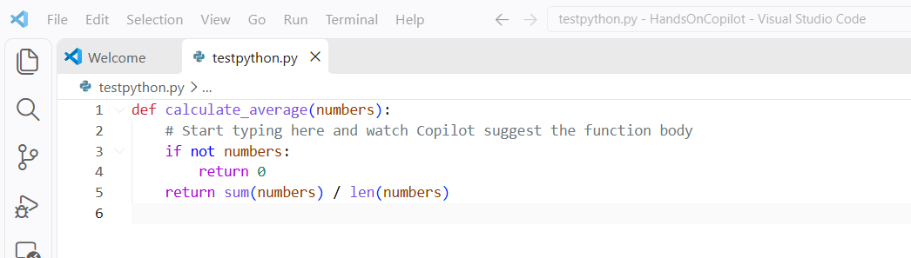
This function was written by copilot just by reading the function name - inline
- Command palette
The command palette provides quick access to the various functions in Copilot, so you can perform complex tasks with only a few keystrokes.
- Open the command palette in Visual Studio Code by selecting Ctrl+Shift+P (Windows or Linux) or Cmd+Shift+P (Mac).
- Enter Copilot to see available commands.
- Select actions like Explain This or Generate Unit Tests to get assistance.
I put in chat generate unit test and below is the result:
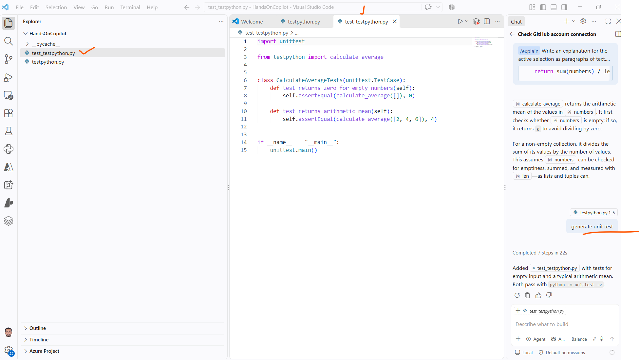

3. Copilot chat
Copilot chat is an interactive feature that enables you to communicate with Copilot by using natural language. You can ask questions or request code snippets, and Copilot provides responses based on your input.
- Open the Copilot chat panel in your IDE.
- Enter questions or requests in natural language, and then evaluate the Copilot response.
4. Inline chat
Inline chat enables context-specific conversations with Copilot directly within your code editor. You can use this feature to request code modifications or explanations without switching contexts.
Inline chat helps you focus on a specific section of your code and receive targeted advice. Additionally, you can utilize slash commands for more efficient interaction.
Here are some common slash commands and their usage:
- /explain - Provides an explanation of the selected code.
- /suggest - Offers code suggestions based on the current context.
- /tests - Generates unit tests for the selected function or class.
- /comment - Converts comments into code snippets.
To use a slash command, just type the command in your editor and press Enter. For example:
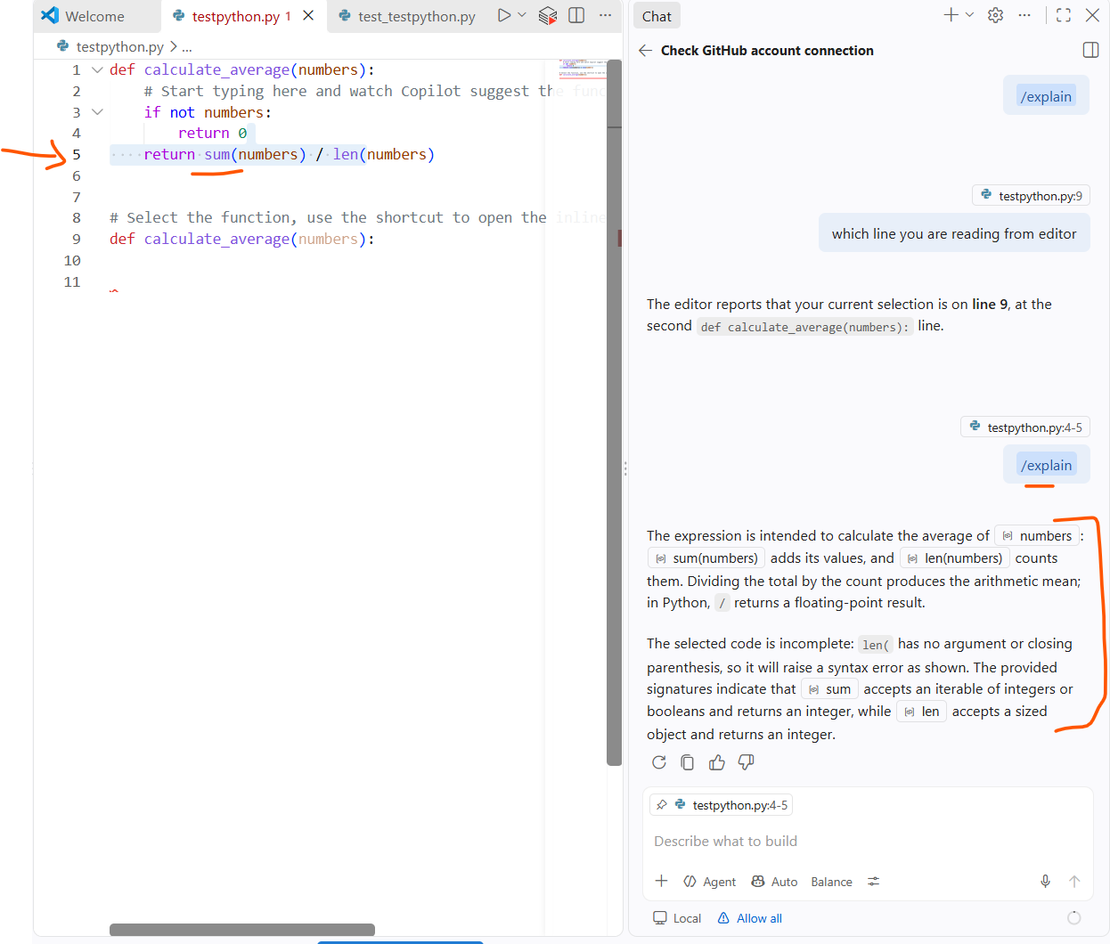

5. Comments to code
Copilot uses natural language processing to convert comments into code. You can describe the functionality that you want in a comment. When you select the Enter key, Copilot generates code based on your description
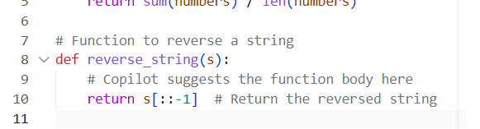

6. Multiple suggestions
For complex code snippets, Copilot can offer multiple alternatives.
- When Copilot offers a suggestion, look for the light bulb icon.
- Select the icon or use Alt+] (Windows/Linux) or Option+] (Mac) to cycle through alternatives.
Multiple suggestions help you explore different coding approaches and select the most appropriate one.
7. Explanations
Understanding existing code is crucial, especially in large projects. You can use the Explain This feature to get explanations for code snippets.
- Select a block of code.
- Right-click the code block, and then select Copilot: Explain This on the shortcut menu.
- Read the explanation that Copilot provides for the selected code.
This feature is useful for learning purposes and when you're reviewing code that someone else wrote.
8. Automated test generation
Unit tests are essential for ensuring code quality and reliability. Copilot can save you time and effort by generating unit tests for your functions or classes.
- Select a function or class.
- Use the command palette to select Copilot: Generate Unit Tests.
- Review the test cases that Copilot suggests for your code.

Keep in mind that Copilot learns from context. Keeping your code well structured and commented helps Copilot provide more accurate and relevant assistance. The more you interact with Copilot, the better it becomes at understanding your coding style and preferences

Set up, configure, and troubleshoot GitHub Copilot

Sign up for GitHub Copilot
Before you can start using GitHub Copilot, you need to sign in with a GitHub account that has access to GitHub Copilot.
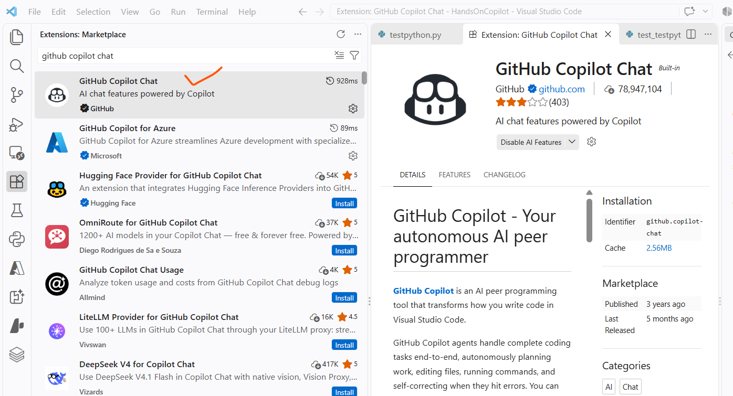

Enable or disable GitHub Copilot in VS Code

- To disable GitHub Copilot completions globally, select Disable completions.
- To disable GitHub Copilot completions for a specified language, select Disable completions for LANGUAGE
Log Folder
Ctrl+shift+p: Developer: Open Log File or Developer: Open Extensions Logs Folder.

Prompt engineering foundations and best practices

Principles of prompt engineering
Before we explore specific strategies, let's first understand the basic principles of prompt engineering, summed up in the 4 Ss below. These core rules are the basis for creating effective prompts.
- Single: Always focus your prompt on a single, well-defined task or question. This clarity is crucial for eliciting accurate and useful responses from Copilot.
- Specific: Ensure that your instructions are explicit and detailed. Specificity leads to more applicable and precise code suggestions.
- Short: While being specific, keep prompts concise and to the point. This balance ensures clarity without overloading Copilot or complicating the interaction.
- Surround: Utilize descriptive filenames and keep related files open. This provides Copilot with rich context, leading to more tailored code suggestions.

How Copilot learns from your prompts
Zero-shot learning
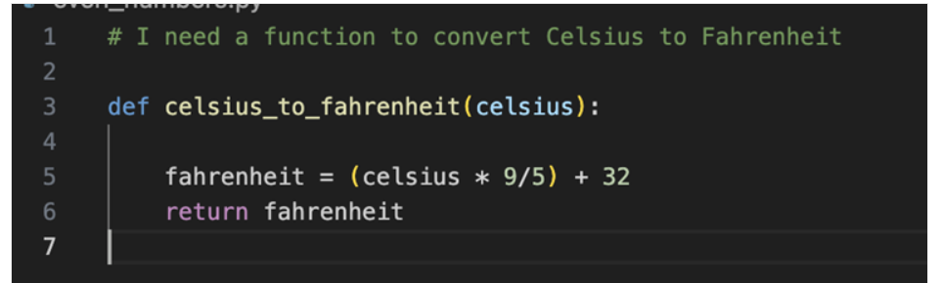
One-shot learning
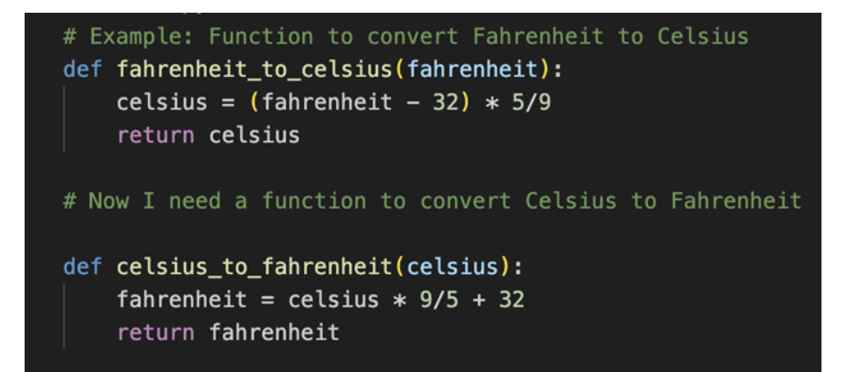
Few-shot learning
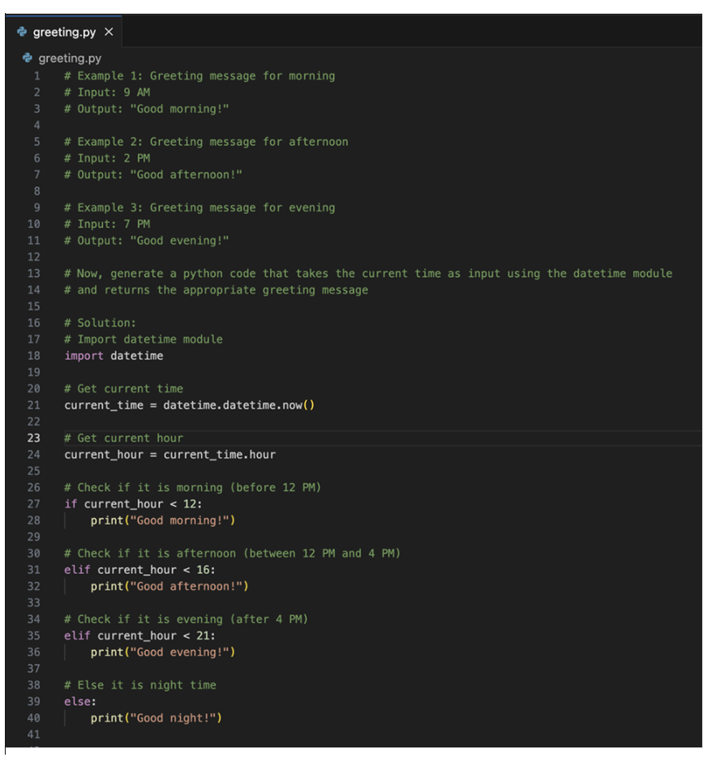

Chain prompting and managing chat history
- Summarize context when conversations become lengthy: "Based on our previous discussion about user authentication, now add rate limiting to prevent brute force attacks"
- Reset and provide focused context for new features: Start fresh with essential details rather than carrying forward the entire conversation
- Use concise references to previous work instead of repeating full implementations

Role prompting for specialized tasks
Role prompting involves instructing GitHub Copilot to act as a specific type of expert, which can significantly improve the quality and relevance of generated code for specialized domains
Security expert role
When working on security-critical features, prompt Copilot to think like a security expert:
"Act as a cybersecurity expert. Create a password validation function that checks for common vulnerabilities and follows OWASP guidelines."
Performance optimization role
For performance-critical code, use a performance expert role:
"Act as a performance optimization expert. Refactor this sorting algorithm to handle large datasets efficiently."
Testing specialist role
When creating comprehensive test suites, leverage a testing expert perspective:
"Act as a testing specialist. Create comprehensive unit tests for this payment processing module, including edge cases and error scenarios.

GitHub Copilot user prompt process flow
Inbound Flow
All the steps Copilot takes to process a user's prompt into a code suggestion.
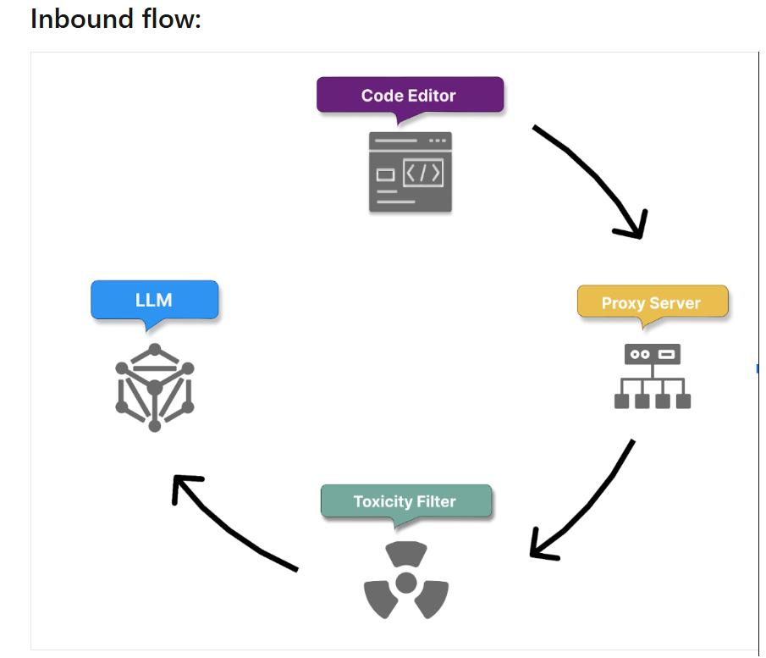
Step1 : Secure prompt transmission and context gathering
The process begins with the secure transmission of the user prompt over HTTPS. This ensures that your natural language comment is sent to GitHub Copilot's servers securely and confidentially, protecting sensitive information.
GitHub Copilot securely receives the user prompt, which could be a Copilot chat or a natural language comment provided by you within your code.
Copilot collects context details:
- Code before and after the cursor position, which helps it understand the immediate context of the prompt.
- Filename and type of the file being edited, allowing it to tailor code suggestions to the specific file type.
- Information about adjacent open tabs, ensuring that the generated code aligns with other code segments in the same project.
- Information on project structure and file paths
- Information on programming languages and frameworks
- Pre-processing using Fill-in-the-Middle (FIM) technique to consider both the preceding and following code context, effectively expanding the model's understanding allowing Copilot to generate more accurate and relevant code suggestions by leveraging a broader context.

FIM breaks your code into three parts:
- Prefix — code before the cursor
- Suffix — code after the cursor
- Middle — the part Copilot needs to generate
Then the model is trained to fill in the missing middle section using both prefix and suffix.
These steps translate the user's high-level request into a concrete coding task.
Step 2 : Proxy filter
Once the context is gathered and the prompt is built, it passes securely to a proxy server hosted in a GitHub-owned Microsoft Azure tenant. The proxy filters traffic, blocking attempts to hack the prompt or manipulate the system into revealing details about how the model generates code suggestions.

Step 3 : Toxicity filtering
Copilot incorporates content filtering mechanisms before proceeding with intent extraction and code generation, to ensure that the generated code and responses don't include or promote:
- Hate speech and inappropriate content: Copilot employs algorithms to detect and prevent the intake of hate speech, offensive language, or inappropriate content that could be harmful or offensive.
- Personal data: Copilot actively filters out any personal data, such as names, addresses, or identification numbers, to protect user privacy and data security.
Step 4 : Code generation with LLM
Finally, the filtered and analyzed prompt is passed to LLM Models, which generate appropriate code suggestions. These suggestions are based on Copilot’s understanding of the prompt and the surrounding context, ensuring that the generated code is relevant, functional, and aligned with project-specific requirements.

Outbound Flow
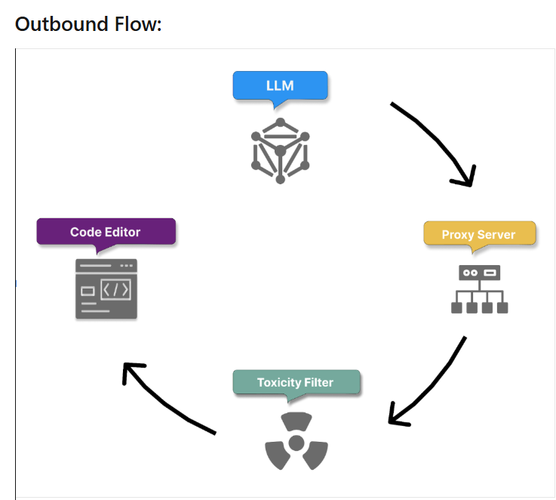
Step 5 : Post-processing and response validation
Once the model produces its responses, the toxicity filter removes any harmful or offensive generated content. The proxy server then applies a final layer of checks to ensure code quality, security, and ethical standards. These checks include:
- Code quality: Responses are checked for common bugs or vulnerabilities, such as cross-site scripting (XSS) or SQL injection, ensuring that the generated code is robust and secure.
- Matching public code (optional): Optionally, administrators can enable a filter that prevents Copilot from returning suggestions over ~150 characters if they closely resemble existing public code on GitHub. This prevents coincidental matches from being suggested as original content. If any part of the response fails these checks, it is either truncated or discarded.
Step 6 : Suggestion delivery and feedback loop initiation
Only responses that pass all filters are delivered to the user. Copilot then initiates a feedback loop based on your actions to achieve the following:
Grow its knowledge from accepted suggestions.
Learn and improve through modifications and rejections of its suggestions.
Step 7 : Repeat for subsequent prompts
The process is repeated as you provide more prompts, with Copilot continuously handling user requests, understanding their intent, and generating code in response. Over time, Copilot applies the cumulative feedback and interaction data, including context details, to improve its understanding of user intent and refine its code generation capabilities.

GitHub Copilot data
How GitHub Copilot handles data for different environments, features and configurations.
Data handling for GitHub Copilot code suggestions
GitHub Copilot in the code editor does not retain any prompts like code or other context used for the purposes of providing suggestions to train the foundational models. It discards the prompts once a suggestion is returned.
GitHub Copilot Individual subscribers can opt-out of sharing their prompts with GitHub which will otherwise be used to finetune GitHub’s foundational model.
Data handling for GitHub Copilot chat
GitHub Copilot Chat operates as an interactive platform, allowing developers to engage in conversational interactions with the AI assistant to receive coding assistance.
- Formatting: Copilot meticulously formats the generated response for optimal presentation within the chat interface. It highlights code snippets to improve readability and may include options for direct integration into your code. Copilot showcases the formatted response in the Copilot Chat window within the IDE, allowing you to easily review and interact with the provided information.
- User engagement: You can actively engage with the response by asking follow-up questions, requesting clarifications, or providing additional input. The chat interface maintains a conversation history to facilitate contextual understanding in subsequent interactions.
- Data retention: For Copilot Chat used outside the code editor, GitHub typically retains prompts, suggestions, and supporting context for 28 days. Specific retention policies for Copilot Chat within the code editor may vary.

Prompt types supported by GitHub Copilot Chat

GitHub Copilot Chat processes a wide range of coding-related prompts
- Direct Questions: You can ask specific questions about coding concepts, libraries, or troubleshooting issues. For example, "How do I implement a quick sort algorithm in Python?" or "Why is my React component not rendering?"
- Code-Related Requests: You can request code generation, modification, or explanation. Examples include "Write a function to calculate factorial," "Fix this error in my code," or "Explain this code snippet."

- Open-Ended Queries: You can explore coding concepts or seek general guidance by asking open-ended questions like "What are the best practices for writing clean code?" or "How can I improve the performance of my Python application?"
- Contextual Prompts: You can provide code snippets or describe specific coding scenarios to seek tailored assistance. For instance, "Here's a part of my code, can you suggest improvements?" or "I'm building a web application, can you help me with the authentication flow?"

Copilot Chat's ability to process diverse input types enhances its utility as a comprehensive coding companion.
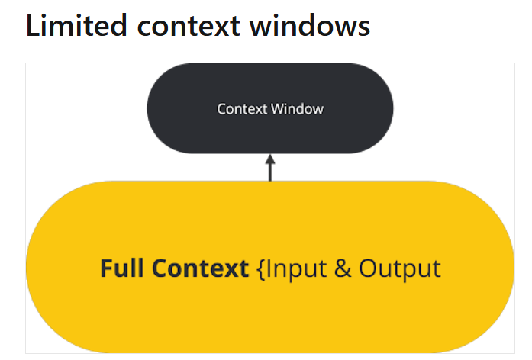
it's essential to acknowledge the limitation of context windows. This refers to the amount of surrounding code and text the model can process simultaneously to generate suggestions.
GitHub Copilot's context window typically ranges from approximately 200-500 lines of code or up to a few thousand tokens.
Copilot Chat currently operates with a context window of 4k token

GitHub Copilot Large Language Models (LLMs)
GitHub Copilot is powered by Large Language Models (LLMs) to assist you in writing code seamlessly.
Role of LLMs in GitHub Copilot and prompting
GitHub Copilot utilizes LLMs to provide context-aware code suggestions. The LLM considers not just the current file but also other open files and tabs in the IDE to generate accurate and relevant code completions. This dynamic approach ensures tailored suggestions, improving your productivity.
Fine-tuning LLMs
Instead of fine tuning billions of LLM parameter , LoRA technique is used . It's used to make large pretrained language models (LLMs) work better for specific tasks without redoing all the training.
Here's how LoRA works:
- LoRA adds smaller trainable parts to each layer of the pretrained model, instead of changing everything.
- The original model remains the same, which saves time and resources.
LoRA fine-tuning is about working smarter, not harder, to make LLMs better for your specific coding requirements when using Copilot.

GitHub Spaces
GitHub Copilot Spaces provides a new way to work with AI by anchoring its responses in a carefully curated context.
Unlike general Copilot Chat, which surfaces broad suggestions, a Space allows you to focus the model on specific files, issues, pull requests, and tailored instructions.
Space : how it works, and why narrowing the context leads to more consistent, reproducible answers
What is a GitHub Copilot Space?
It’s a dedicated Copilot chat grounded in a curated set of context you choose
It is feeded with GitHub files, issues, pull requests, and own free-text instructions to provide context to the specific topic

Setting Context for Copilot Spaces
The effectiveness of a Copilot Space depends on the context provided. We can attach specific files (such as scripts, configuration, or documentation), relevant issues or pull requests, and tailored instructions. By curating this input, we help Copilot focus on the information that matters most for our scenario. The context order matters: leading with the most critical files or instructions helps drive more accurate and relevant responses
Setup: Attaching Files (Uploads) and Instructions in Copilot Spaces
Attaching Files (Uploads):
- In the Space setup, use the "Attach files" or "Add context" button to select one or more files from GitHub repository.
- Attach source code files, markdown docs, configuration files, or other assets as context. These files are referenced from the default branch, so the Space stays up to date as the repo evolves.
- If allowed by workspace settings, we may also upload files directly (such as images or datasets) from our local machine for non-repo context.
Adding Instructions:
- Use the "Instructions" section to provide specific guidance to Copilot. This can include goals ("Summarize the onboarding process"), style preferences ("Write in a formal tone"), or canonical examples ("Sample output should look like…").
- Keep instructions brief, focused, and actionable. If the Space serves a workflow or troubleshooting guide, include step-by-step tasks or sample prompts.
- Update the instructions at any time to refine the focus of the Space.

Best Practise:
- keep Spaces small and focused
- Linked GitHub files reflect the repository's default branch, helping content stay current as code evolves.
- Be clear and concise with your instructions and include a few canonical examples to anchor style and expected outputs
- Finally, remember that the selection and ordering of context can influence responses, so lead with most important sources.

Creating Space
Creating a Space is simple but powerful—once named and configured, it becomes a reusable workspace where Copilot operates within a clearly defined scope
- To create a space, go to https://github.com/copilot/spaces, and click Create space.
- Give your space a name.
- Choose whether the space is owned by you or by an organization you belong to. Organization-owned Spaces can be shared using GitHub's built-in permission model.

- Optionally, add a description. This doesn't affect the responses Copilot gives in the space, but it can help others understand the context of the space.

- Click Save in the top right corner of the page.
- Adding context to a space You can add two types of context to the space:
Instructions: Free text that describes what Copilot should focus on within this space. Include its areas of expertise, what kinds of tasks it should help with, and what it should avoid. This helps Copilot give more relevant responses based on your intent.
Attachments: This context is used to provide more relevant answers to the questions. Additionally, Spaces always refer to the latest version of the code on the main branch of the repository.
To add attachments, click Add to the right of "Attachments", then choose one of the following options:
- Attach files and folders: You can add files and folders from your GitHub repositories. This includes code files, documentation, and other relevant content that can help Copilot understand the context of your space.
- Link pull requests and issues: we can paste the URLs of the GitHub issues and pull requests.
- Upload a file: we can upload files directly from our local machine. This includes images, text files, rich documents, and spreadsheets.
- Add text content: we can type or paste free-text content, such as transcripts, notes, or any other relevant information that can help Copilot understand the context of the space

Visibility and sharing
Successful Spaces are easy to find, safe to share, and clearly "owned."
When you create a Space, set visibility according to how broadly you intend others to use it.
Depending on the environment, options may include keeping it under your personal ownership or making it visible to the organization.
Share the Space by link and, where available, rely on org-level browsing or catalogs to improve discoverability. Use a clear, purpose-driven title, and a short description that states the scope ("one job per Space"), intended audience, and expected outputs so teammates immediately know when to use it.

Security & Access
Security follows GitHub's existing permissions. A Space doesn't grant new access; it only surfaces content that viewers are already entitled to see.
If a Space links to private repositories, issues, or pull requests, only users with the appropriate repo permissions see that material reflected in answers. This helps share confidently across an organization while keeping sensitive information protected.
As a best practice, avoid pasting sensitive data into free-text notes; prefer linking to version-controlled files where normal review and permissions apply.

Versioning and freshness
Spaces stay fresh by referencing live GitHub sources. Linked files reflect the repository's default branch, and attached issues and pull requests evolve as they change, reducing the need to copy content into separate documents.

Governance
Assign an owner who maintains the Space, add a short "How to use this Space" note at the top of the instructions, and include 1–3 canonical examples that define "good" output
When a Space grows beyond a single job, split it into smaller Spaces so discoverability stays high and answer quality remains consistent.

Checklist for creating space
Use this checklist when creating or updating a Space to keep it easy to find, safe to share, and reliably useful.
Naming and Purpose
- [ ] Choose a clear, purpose-driven title (for example, "ServiceName—Onboarding Helper"); keep "one job per Space."
- [ ] Write a 1–2 sentence description that states scope, intended audience, and expected outputs.
- [ ] Add a brief "How to use this Space" note at the top of the instructions.
Ownership and Visibility
- [ ] Set the correct owner (individual or organization, if available).
- [ ] Select appropriate visibility (private, org-visible, etc.).
- [ ] Verify access with a non-owner who expected GitHub permissions (Spaces inherit repo/issue/PR permissions).
- [ ] Share the URL and, where available, add collaborators.

Security and Privacy
- [ ] Don't paste sensitive data into free-text; prefer linking version-controlled files where normal review/permissions apply.
- [ ] Ensure all attached sources are suitable for the chosen visibility.
- [ ] If uploads are supported, limit the text content you’re comfortable sharing.
- [ ] Remove obsolete or confidential materials.

Discoverability and Docs
- [ ] Use consistent naming conventions across Spaces (team/service prefixes help).
- [ ] Add tags/keywords in the description to aid search.
- [ ] Announce or catalog the Space in your org’s preferred directory/channel.
Review Cadence and Governance
- [ ] Assign a maintainer/owner responsible for updates.
- [ ] Set a review cadence (for example, monthly or per release).
- [ ] At each review: validate links, test 2–3 representative prompts, update examples, prune noisy sources, and confirm visibility.
- [ ] Track feedback and improvement requests (issues, discussion, or a simple checklist in the description).

Do's and Don'ts of Working in a Space

Do’s | Don’ts
Do keep questions tightly scoped to the sources attached—files, issues, pull requests, and notes—so answers stay grounded | Don't @-mention people or other Copilot extensions in a Space: user mentions won't notify anyone, and extensions can't be invoked from Space chats.
Do treat the Space as a focused environment for a single task or domain, and reuse its own terminology to reinforce consistency. | Don't expect the Space to pull in content that isn't included—unless your environment supports repository search you've explicitly attached, Copilot won't discover outside material.
Do use prompting patterns that lead to runnable, verifiable outputs. Start by confirming intent, then refine with concrete constraints (formats, time ranges, file paths, or sections to consider). Ask for executable code, queries, or commands and, when helpful, request references back to the included sources for traceability | Don't let the Space sprawl beyond a single job or exceed model context limits; if you hit size warnings or degraded answers, reduce sources or split into smaller Spaces to restore precision and predictability
Do iterate when responses drift: tighten instructions, add one to three high-quality examples that demonstrate "good" output, and prune noisy or irrelevant sources. | Don't paste sensitive data into free-text notes; prefer linking to files in repos (or use uploads where supported) so standard review and permissions apply.
Do keep context fresh and well-ordered. Link version-controlled files so the Space reflects your repository's default branch as it evolves, and lead with the most important sources or examples since ordering can influence responses.

Exercise - Democratize tribal knowledge using Copilot Spaces
Step 1: Create and prime Copilot Space
In this step we will establish a Copilot Space and give it the minimum context it needs to act as a project management knowledge hub for OctoAcme
Theory: Using Copilot Spaces as a Knowledge Hub
GitHub Copilot Spaces enables teams to centralize and democratize organizational knowledge by providing a collaborative environment for storing, searching, and refining process documentation
By connecting the repository as a source, Copilot Spaces index the documentation and issue templates, making them easily accessible and actionable for all team members.
Created a Space,added Repository as a Source to Copilot Space
Step 2: Add Instructions to Copilot Space
Locate the Instructions panel inside your Copilot Space interface.
Draft a clear, role-specific instruction block. For example:
"You are an experienced technical project manager and software engineer working on this repository. Always ground your responses in the documentation and files attached to this space. Be concise, structured, and reference specific files when explaining workflows.

Step 3: Create Issues in the Repository Using Copilot Spaces
Use the chat interface within Copilot Space to prompt the model about upcoming features, tasks, or missing components identified in repository files.
Ask Copilot: "Based on our documentation, help me draft an issue breakdown for implementing our next milestone."
Review the generated breakdown and use the suggested details to create the issues directly within the repository.
Step 4: Explore and Summarize Project Management Process Documentation
Prompt Copilot inside space with questions like: "Summarize our current project management lifecycle, tracking protocols, and contribution guidelines based on the attached files."
Review the synthesized summary. Copilot will cross-reference different Markdown files, past issues, and documents to give an evergreen overview.

Step 5: Update Repository Documentation Based on Insights and Gaps Discovered
Asked Copilot to draft a revision for a documentation file (e.g., CONTRIBUTING.md, README.md, or a workflow guide) addressing the gaps discovered in Step 4.
Applied the changes, commit them to repository (or open/merge a pull request if you are following the automated step validation workflow).
Verify our automated GitHub Actions check passes to clear the final exercise step.

Advanced GitHub Copilot features
when we work with code, we need to review the project's documentation in addition to libraries and framework documentation. In order to write code or documentation, we must have a good understanding of the codebase. Tasks like fixing bugs and writing tests can be time intensive, but at the same time necessary for most projects. Fortunately, GitHub Copilot has several advanced features that can make these tasks easier and more efficient.

The basics
When GitHub Copilot is enabled, it provides you with suggestions. These suggestions are called ghost text. You can either ignore the ghost text, or accept it by pressing the Tab key. The suggestions don't require a prompt because by default GitHub Copilot uses the files you have open as context. However, you can provide a prompt using a comment, the chat window, or the inline chat within your code.
Chatting with GitHub Copilot
GitHub Copilot allows you to have an interactive discussion using the chat feature. In Visual Studio Code, you can click the chat icon on the left sidebar, which opens the chat interface in a dedicated pane.
In this pane, you can ask questions about the code you're currently working on or other software-related questions.
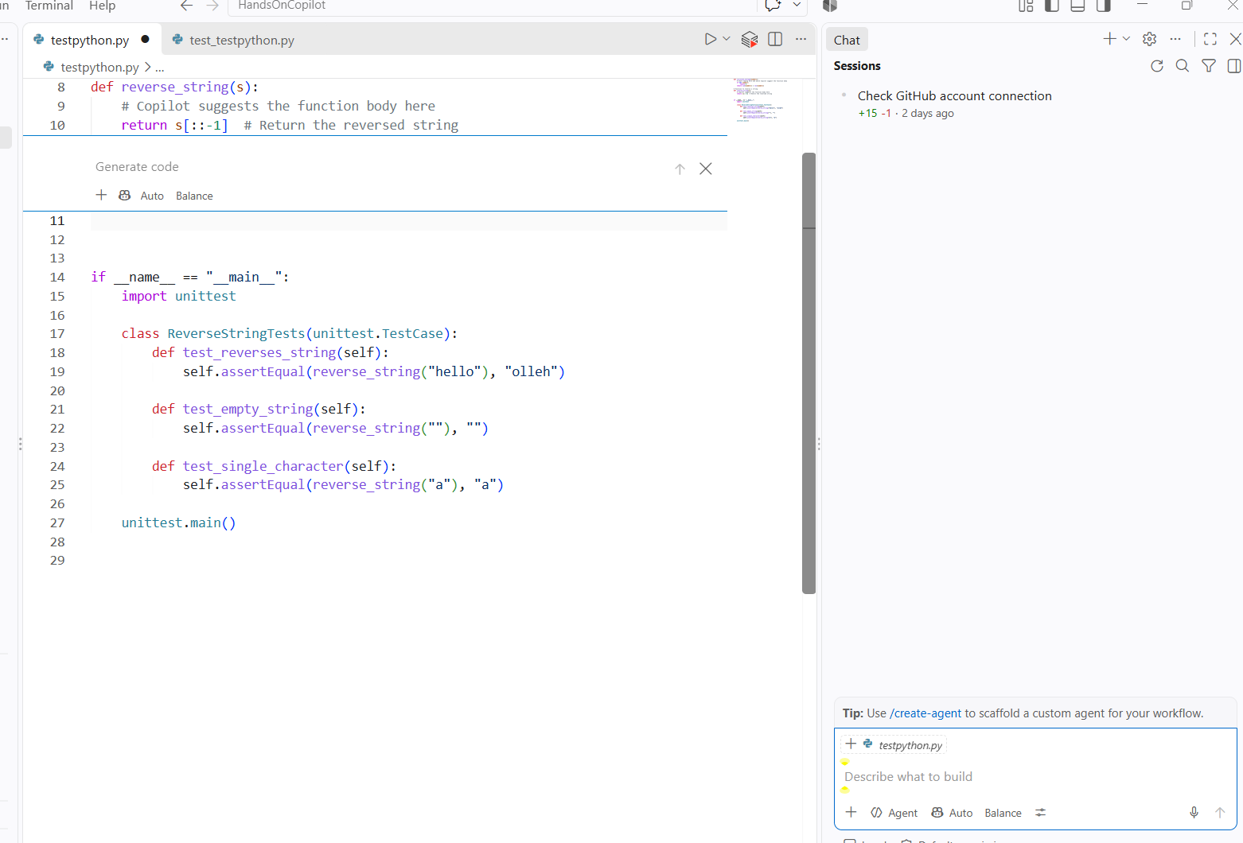

Using inline chat
Besides the dedicated chat pane, you can use the inline chat. It allows you to interact with GitHub Copilot without leaving your code.
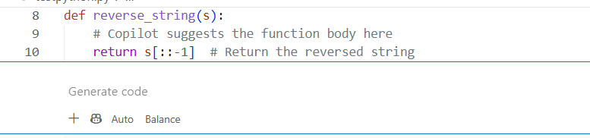
Slash commands
Within the chat pane or when using the inline chat, you can use slash commands. These commands allow GitHub Copilot to use a specific intent for quickly solving common development tasks.
If you type a forward slash in the chat pane or inline chat, you should see a drop-down menu with all the slash commands available. For example, the /tests slash command helps you write tests, while the /docs command is intended for writing documentation.
Using specific slash commands to create a question is a good way to get better responses without having to write longer prompts.

Agents
Visual Studio Code has a feature called agents that allows you to interact with GitHub Copilot. These agents allow you to ask questions using a specific context. For example the @terminal agent helps you chat with GitHub Copilot to interact with the terminal.
Examples:
- “@terminal” → use the terminal agent
- “@workspace” → use the workspace context
- “@vscode” → use VS Code-specific help
So the syntax is basically:
- @agentName + your question

Code completion with GitHub Copilot
GitHub Copilot integrates seamlessly with editors like Visual Studio Code or JetBrains
GitHub Copilot supported languages
- Python
- JavaScript
- Java
- TypeScript
- Ruby
- Go
- C#
- C++

Auto suggestions

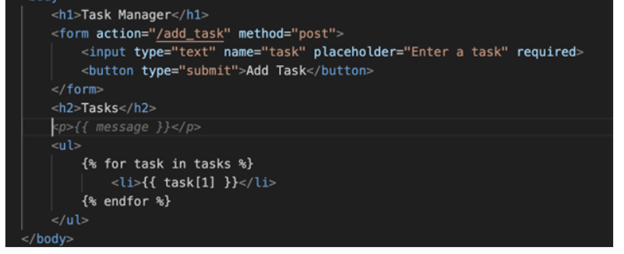

Multiple suggestions pane
When working on a code block and GitHub Copilot offers a suggestion, we see a grayed-out code snippet.
Hover over the suggestion to reveal the GitHub Copilot control panel, This feature allows to quickly evaluate multiple approaches to the same problem, helping choose the most suitable solution for your specific context.
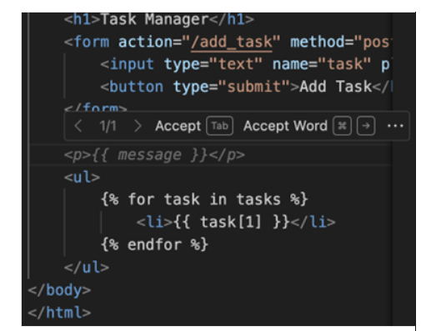
While GitHub Copilot is superb at suggesting code , it also demonstrates its ability to adapt through the following ways:
- Method Implementation: When we start typing a method name, Copilot can suggest the entire implementation, following the established coding style.
- Naming Conventions: It picks up on the preferred naming conventions for variables, functions, and classes.
- Formatting: Copilot adapts to our indentation style, bracket placement, and other formatting preferences.
- Comment Style: It can mimic our comment style, whether we prefer inline comments, block comments, or doc strings.
- Design Patterns: When the project consistently uses certain design patterns, Copilot suggests code that aligns with these patterns.

Using coding comments for suggestions
- Natural Language Processing: Copilot uses advanced natural language processing (NLP) techniques to interpret the meaning and intent behind comments in the code.
- Contextual Analysis: It analyzes comments in relation to the surrounding code, understanding their relevance and purpose within the broader context of the file or project.

Types of comments utilized
Copilot can work with various types of comments to inform its suggestions:
- Inline comments: Short explanations next to specific lines of code.
- Block comments: Longer explanations that might describe a function or class.
- Docstrings: Formal documentation strings in languages like Python.
- TODO comments: Notes about future implementations or improvements.
- API Documentation: Comments that describe the usage and parameters of functions or methods.

Comment-driven code generation
Copilot uses comments in several ways to generate and suggest code:
- Function implementation: When a function is described in comments, Copilot can suggest an entire implementation based on that description.
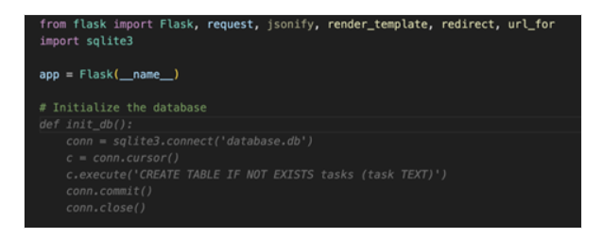
Code completion: Copilot uses comments to provide more accurate code completions, understanding the developer's intent
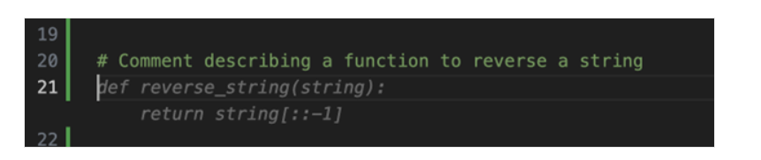

Variable naming: Comments can influence Copilot's suggestions for variable names, making them more descriptive and context-appropriate.
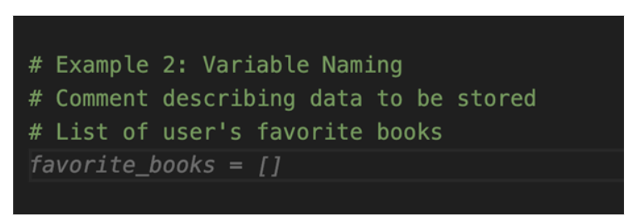

Algorithm selection: When comments describe a specific algorithm or approach, Copilot can suggest code that aligns with that method
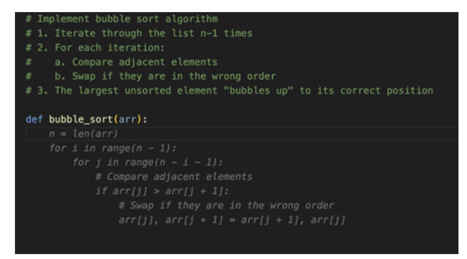

GitHub Copilot Chat
GitHub Copilot Chat is an advanced feature of the GitHub Copilot ecosystem, designed to provide developers with an interactive, conversational AI assistant directly within their development environment
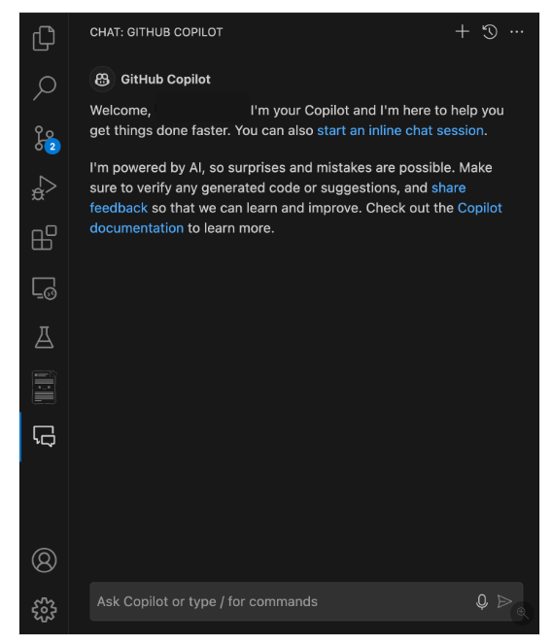
GitHub Copilot Chat is beneficial in certain scenarios:
- Complex code generation
- Debugging assistance
- Code explanations

How to improve GitHub Copilot Chat responses
We can significantly improve the quality and relevance of GitHub Copilot Chat's responses with certain key features
- Scope referencing
To enhance the accuracy and relevance of the responses provided by GitHub Copilot Chat, it’s important to properly scope questions using references
File references: specify a particular file in the question by adding a #file: before the file name

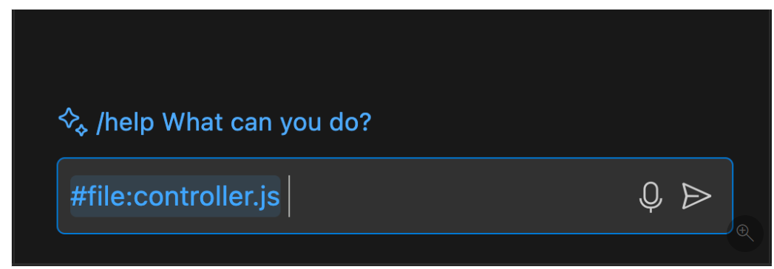

For example, if working with a file named controller.js, use the #file command to select it and reference it directly in the question as #file:controller.js. This feature tells Copilot Chat to focus on the contents of that file when generating a response.
Environment References
Use Copilot Chat alongside the terminal to get help based on command output.
For example, asking “@terminal how do I fix this error?” lets Copilot analyze the terminal output and suggest relevant solutions.
- Slash commands
Slash commands in GitHub Copilot Chat allows to quickly specify the intent of the query
This can significantly improve the quality of the responses received by making the requests more focused.
some commonly used slash commands:
- /doc: type /doc followed by the code you want to document, and Copilot generates appropriate comments.
- /explain: Provides explanations for selected code
For example, /explain the #file:controller.js gives a detailed explanation of that file.
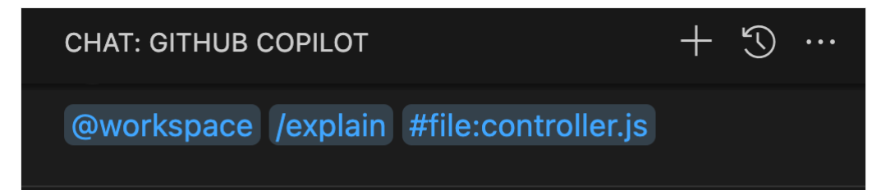
- /fix: Proposes fixes for problems in the selected code
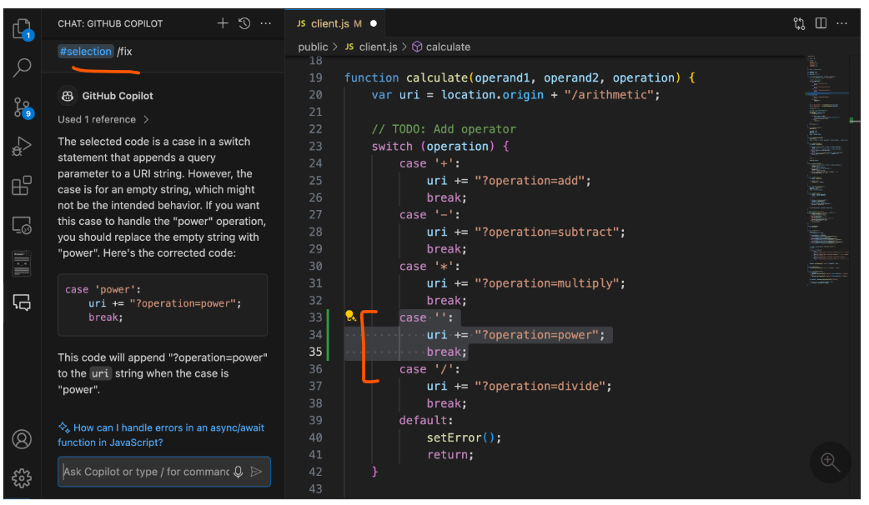
- /generate: Helps in generating new code based on the requirements.
For example, /generate code to find the root of a number in client.js
- /optimize : Analyzes and suggests improvements to the running time or efficiency of the selected code
For example: /optimize the calculate method in controller.js
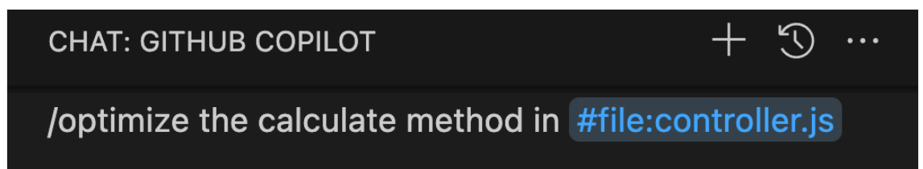

- /tests: creates unit tests for the selected code
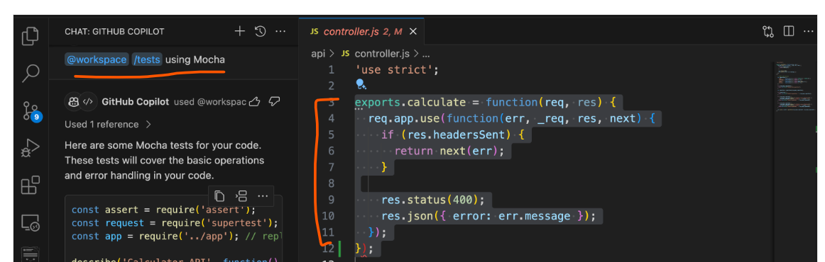

Model selection and premium features
GitHub Copilot Chat offers different AI models to optimize your development workflow
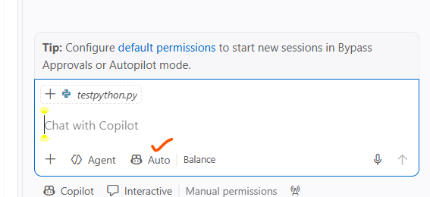
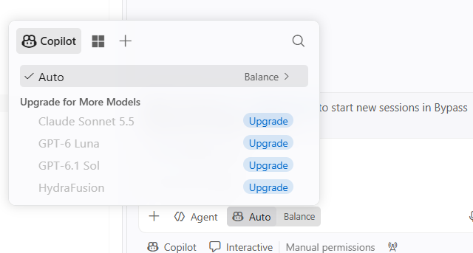

Copilot Agents
GitHub Copilot agents are custom tools that we can build and integrate with GitHub Copilot Chat to provide additional functionalities tailored to our specific needs
In addition to slash commands, use specific agents within Copilot Chat in IDE to handle different tasks:
Require : Copilot Pro, I only have Copilot Free plan

GitHub Copilot on GitHub.com
When working with repositories, issues, pull requests, and discussions on the GitHub web interface, n leverage Copilot's capabilities to streamline workflow and enhance collaboration.

Accessing Copilot on GitHub.com
Copilot is integrated throughout the GitHub web interface, appearing as a chat button or inline suggestions in various contexts. Access Copilot features in several areas:
- Repository pages - Get explanations of code, documentation, and project structure
- Issues and pull requests - Generate summaries, suggest solutions, and draft responses
- Discussions - Help formulate responses and provide technical insights
- Code review - Analyze changes and suggest improvements

GitHub Copilot Agent tasks on GitHub.com
When using Copilot on GitHub.com, we can perform various agent-driven tasks:
- Repository exploration and documentation
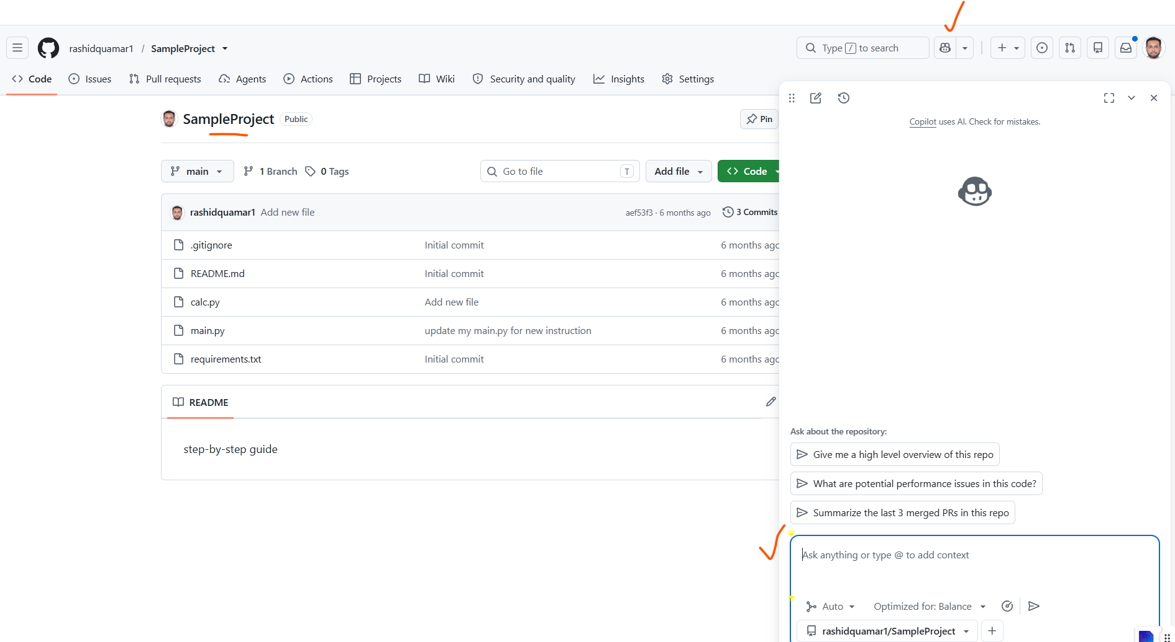
Go to the repository on GitHub.com : SampleProject
Click Issues → New Issue
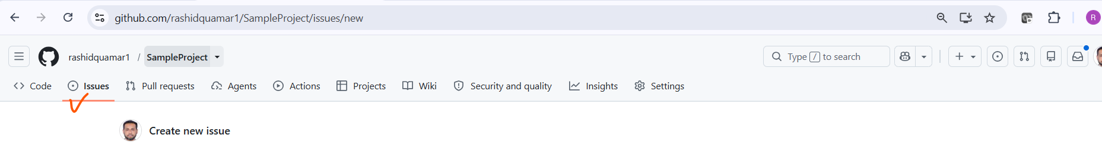

Paste the entire block above :
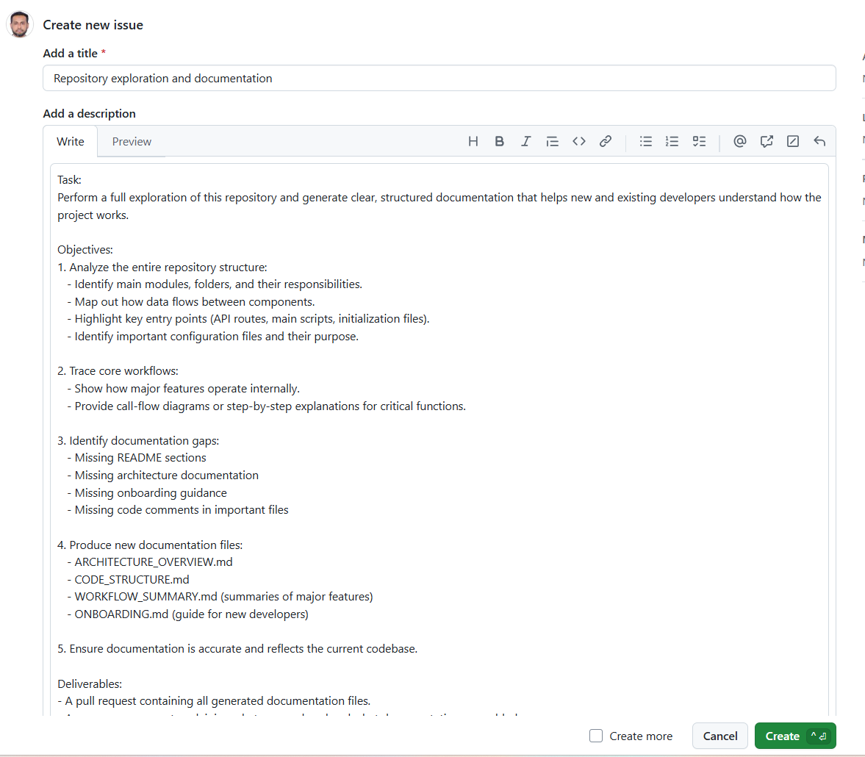

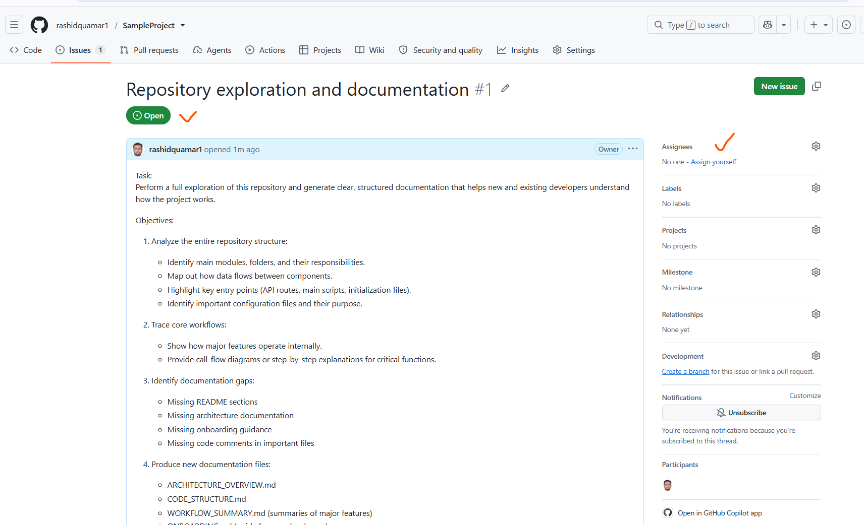
Assign the issue to @github-copilot
Note : I am on the Free plan
Free plan does NOT include Copilot Agents
Therefore @github-copilot will not appear in the assignee list
- Pull request assistance
GitHub Copilot on GitHub.com significantly accelerates the pull request workflow by automating many time-consuming review and documentation tasks:
- PR summaries: Generate comprehensive summaries of changes made in a pull request, helping reviewers quickly understand the scope and impact of modifications
- Review suggestions: Get recommendations for code improvements and potential issues before formal review, reducing review cycles
- Merge conflict resolution: Receive guidance on resolving conflicts between branches, streamlining the merge process
- Documentation updates: Automatically suggest updates to README files, changelogs, and other documentation based on code changes
Example: "Summarize the changes in this pull request and highlight any potential concerns"

- Issue management
Issue analysis: Break down complex problems into actionable tasks
Solution brainstorming: Generate potential approaches to resolve reported issues
Reproduction steps: Help create clear steps to reproduce bugs or issues
Example: "Analyze this issue and suggest potential solutions with implementation approaches"
- Code review and collaboration

GitHub Copilot enhances the code review process by providing intelligent insights and suggestions that help maintain high code quality and catch potential issues early:

- Review comments: Generate thoughtful code review comments with specific suggestions
- Security analysis: Identify potential security vulnerabilities or best practice violations
- Performance optimization: Suggest improvements for code efficiency and performance
Example: "Review this code change and provide feedback on security and performance considerations"
- GitHub Copilot Explain error in actions

GitHub Copilot can help explain and resolve errors that occur in GitHub Actions workflows. This feature analyzes failed workflow runs and provides insights into what went wrong and how to fix it.

- Error analysis: Copilot examines log files and identifies the root cause of failures
- Solution suggestions: Provides specific recommendations to resolve workflow issues
- Best practices: Offers guidance on improving workflow reliability and performance
- Context awareness: Understands the relationship between different workflow steps and dependencies

GitHub Copilot for the Command Line
GitHub Copilot isn’t just for Integrated Development Environments(IDEs)—it’s a powerful assistant in terminal.
GitHub Copilot CLI brings Copilot directly into the command line, Copilot CLI uses GitHub authentication and runs independently from GitHub CLI

Installing and launching Copilot CLI

To install : winget install GitHub.Copilot
copilot --version
Launch Copilot CLI : copilot
Authenticate: /login
Use slash commands (/command) to control the session and configure Copilot CLI.
copilot -i "suggest find large files and delete them"
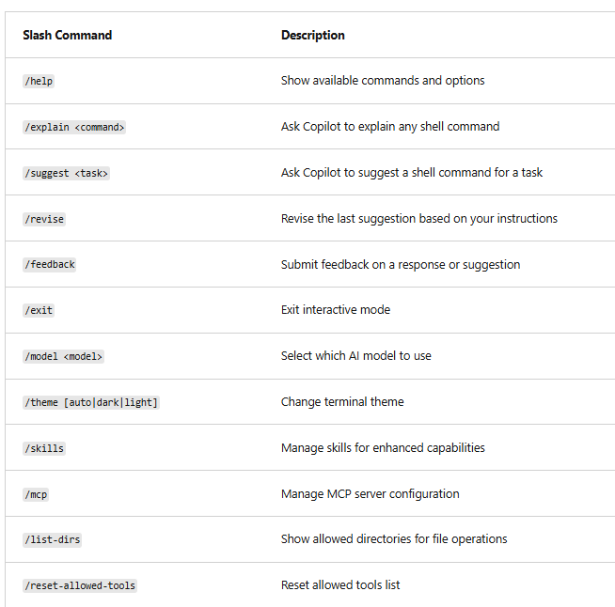

Configuration options
In Copilot CLI, configuration is handled via:
- Slash commands inside interactive mode
  - /model choose AI model
  - /theme change terminal theme
  - /skills manage enhanced capabilities
  - /reset-allowed-tools reset tools
  - /list-dirs view allowed directories
  - /mcp MCP server settings
- Copilot CLI configuration
Copilot CLI configuration is managed through permission prompts, command-line flags, and local configuration files.

Sandboxed execution environments
GitHub Copilot CLI supports sandboxed execution environments that help protect the system
Sandboxing isolates commands, file operations, and other activities from the primary development environment.
Depending on the workflow, we can choose between local sandboxing and cloud sandboxing.

Local sandboxing
Local sandboxing allows Copilot to execute commands inside a restricted environment on the local machine.
When enabled, Copilot's access to local filesystem, network connectivity, and operating system. Capabilities is limited, helping reduce the risk of unintended changes while still allowing to benefit from agent-assisted workflows.
To enable local sandboxing during an interactive session: /sandbox enable

Benefits of local Sandboxing
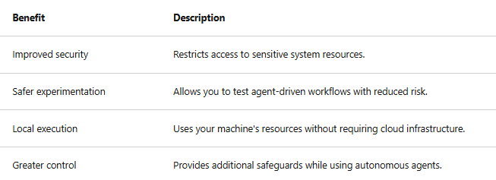

Cloud sandboxing
Unlike local sandboxing, cloud sandbox sessions execute entirely in GitHub-hosted infrastructure and remain separate from the local machine and from other sandbox sessions.
Copilot CLI sessions run inside fully isolated Linux environments hosted by GitHub
Cloud sandboxing is built on Azure Container Apps with GitHub providing authentication, governance, policy enforcement, and billing integration.
To start a cloud sandbox session: copilot --cloud
Benefits of cloud sandboxing
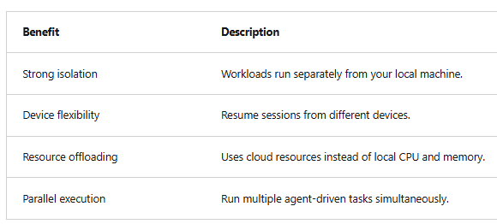

Sessions across devices
Cloud sandbox sessions run in GitHub-hosted infrastructure(Linux env), work is not tied to a specific computer.
This allows you to:
- Start a session on one device
- Resume the same session from another device
- Continue work without manually transferring files or recreating environments
This flexibility is especially useful for developers who work across multiple machines or locations.

Cloud sandbox sessions exist in three states:
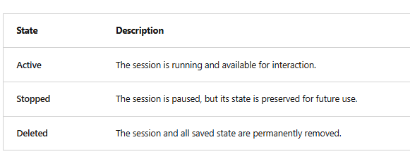

Authentication and access
Cloud sandboxes authenticate exactly like Copilot CLI:
sign in with GitHub OAuth or provide a GitHub token, and the sandbox session uses that token to access Copilot features.
When should we use sandboxing?
Cloud sandboxing runs Copilot inside an ephemeral Linux environment hosted by GitHub. It is completely isolated from your machine and other sessions
Use cloud sandboxing when:
- You want maximum isolation
- You don’t want Copilot touching your local system at all
- You need a clean, reproducible environment
- You want to run commands without installing dependencies locally
- You want to avoid local security risks
Question: does this means if I have my complete project in github , I can run the project and test it is an isolated environment
Ans : Yes. You can run, test, and experiment with your GitHub project inside a cloud sandbox — a clean, isolated Linux environment — without installing anything locally.

GitHub Copilot App
The GitHub Copilot app is a native desktop experience for macOS, Windows, and Linux that provides developers with a single place to manage their work end-to-end—from selecting what to build to shipping code.
It brings together:
- Agent-based development
- Code changes and diff review
- Pull request workflows (checks, feedback, and merge)
All within one application connected directly to GitHub.
GitHub Copilot app: A home for end-to-end work
Instead of switching between multiple tools, the Copilot app allows developers to:
- Start from an issue or task
- Generate and iterate on code
- Review changes
- Manage pull requests
- Complete the merge process
This is all accomplishable without leaving the app.

The GitHub Copilot app addresses these challenges by:
- Consolidating workflows into a single experience
- Automatically creating isolated workspaces for parallel tasks
- Keeping code, context, and pull request lifecycle tightly connected

In legacy world: Imagine fixing a bug in the project.
We normally have to jump between:
- VS Code → to edit code
- Terminal → to run commands
- Browser → to open GitHub issues
- Another browser tab → to review pull requests
- Copilot Chat → inside VS Code
- GitHub Actions page → to check CI results
We are constantly switching windows, tabs, tools, and contexts. It’s slow, distracting, and easy to lose track of what you were doing.
With the GitHub Copilot app (the new way)
Everything happens inside one single app:
✔️ You open the GitHub Copilot app- It shows your repo, issues, branches, and PRs.
✔️ You click an issue- Copilot creates a branch and starts working on it.
✔️ You chat with Copilot - It edits code, runs commands, and tests changes inside a sandbox.
✔️ You review the pull request - Right inside the same app — no browser needed.
✔️ You merge the PR - Still inside the same app.
✔️ You start another task - In a parallel agent session, without leaving the app.
Old way: You use 6–7 different tools to fix one bug.
New way (Copilot app): You use one app to do everything — code, chat, run, test, review, merge.

Ques: What is Automatically creating isolated workspaces for parallel tasks
Ans: Imagine we have a GitHub project and want to :
Task A: Fix a bug in the login page
Task B: Add a new “Forgot Password” feature
With traditional development, we would do:
- Fix the bug
- Commit
- Switch branches
- Add the new feature
- Commit
- Create PRs
- Review both
All one after the other.
With Parallel Agent Workflows (Copilot App)
You open the GitHub Copilot app.
✔️ Agent 1 works on the login bug
- Creates a branch fix-login-bug
- Runs tests in a sandbox
- Makes code changes
- Prepares a PR
✔️ Agent 2 works on the new feature
- Creates a branch feature-forgot-password
- Generates UI + backend logic
- Runs tests
- Prepares a PR
Both agents run at the same time, in separate sandboxes, on separate branches.
We don’t wait for one to finish before starting the other.
Each agent works on its own branch. When an agent finishes its task, it creates a pull request (PR). You decide when to merge
When do you merge Code?
We merge after reviewing each PR, typically when:
- The agent finishes its work
- Tests pass
- You approve the changes
- Click Merge inside the Copilot app
The merge happens only when we choose, not automatically.

How the GitHub Copilot app works
At the core of the GitHub Copilot app experience are task sessions:
- Each task session is tied to a specific Git branch or pull request.
- Sessions are isolated using Git worktrees, ensuring changes stay scoped to that branch.
- Multiple task sessions can run in parallel without interfering with each other.
This enables developers to orchestrate multiple streams of work simultaneously, each in its own isolated environment.
Built on Copilot CLI
The app is powered by the Copilot CLI runtime, meaning:
- Existing CLI setups carry forward
- Developers can reuse their tools, skills, and configurations
- Advanced workflows remain compatible
GitHub Copilot app is built on GitHub Copilot CLI, it supports CLI session history capabilities such as /chronicle. This allows developers to gain insights from previous work completed across both the GitHub Copilot app and Copilot CLI sessions.
Common use cases
- /chronicle standup: Generate a summary of recent work completed across sessions.
- /chronicle Review previous activity and session history.

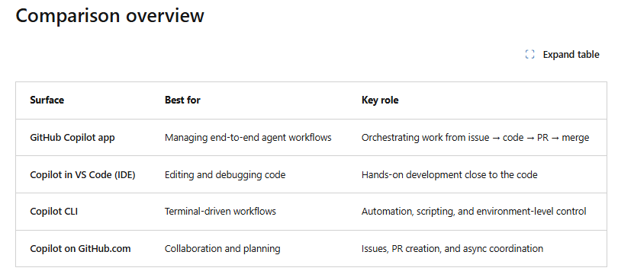

Voice dictation
The GitHub Copilot app supports voice dictation, allowing you to speak prompts instead of typing them.
Configuring Voice dictation
Before using voice dictation:
- Open Settings in the GitHub Copilot app.
- Select the Voice Dictation tab.
- Choose a keyboard shortcut.
- Grant microphone permissions in your operating system.
- Download the local transcription model.

GitHub Copilot plans – Management and Customization
GitHub enables developers and organizations to maximize their potential by prioritizing security, privacy, compliance, and transparency

Management policy features
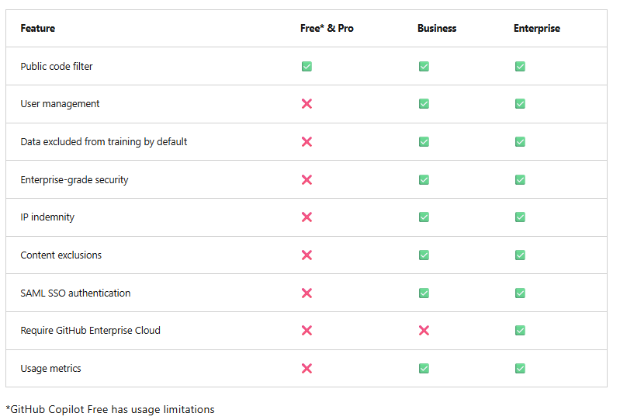
Public code filter means setting that detects Copilot suggestions that resemble public GitHub code and either blocks them or shows references to the original repositories.
Data excluded from training by default : GitHub Copilot has strict rules about what data is never used to train or retrain its AI models. These rules protect your organization’s intellectual property, private code, and sensitive information.
Copilot doesn’t need to train on our private code to give accurate answers. It uses your real-time context — the files you open, the code you write, the repo structure, the symbols, the functions, the patterns — to generate highly relevant suggestions.
Think of it like this:
Training = long-term learning
Context = short-term understanding of our current repo
Copilot uses the second one, not the first.
Content exclusions means categories of data Copilot is forbidden from using for model training — such as private code, sensitive data, secrets, chat prompts, and enterprise content.

Customization features
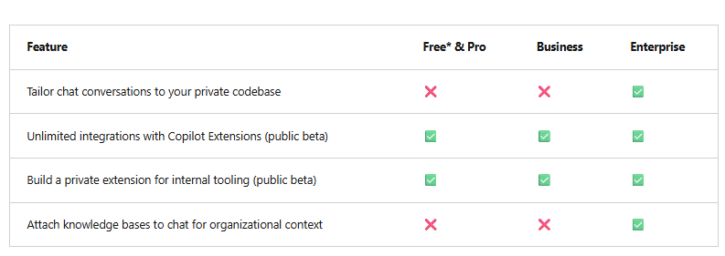
Build a private extension : It means the organization can create custom Copilot extensions that integrate the internal systems, tools, APIs, workflows, or business logic, and make them available only inside the company.
Think of it as building own private Copilot plugin.
Go to GitHub → Organization Settings → Copilot → Extensions
Admins only.
There you will see:
- Add extension
- Upload manifest
- Configure endpoint
- Set permissions (who can use it)

Attach knowledge bases to chat for organizational context : this is done by creating Copilot Spaces
The alternative is by using Microsoft Copilot Studio Agents ( out of scope , not essential)

Contractual protections in GitHub Copilot and disabling matching public code
Contractual protections means GitHub’s legally binding commitments that Copilot will not use the private code, data, or prompts for training, and will protect IP, privacy, and security under the GitHub Enterprise agreement.

Contractual protections
- IP Idemnity : A legal promise to protect if something goes wrong — including paying costs, damages, and defending in court.
- Data Protection Agreement (DPA):
- GitHub Copilot Trust Center

Filtering out matching public code
GitHub Copilot can help minimize potential code overlap by identifying and filtering out code suggestions that match publicly available code
It can reduce the risk of incorporating nonsecure or noncompliant code into the projects.
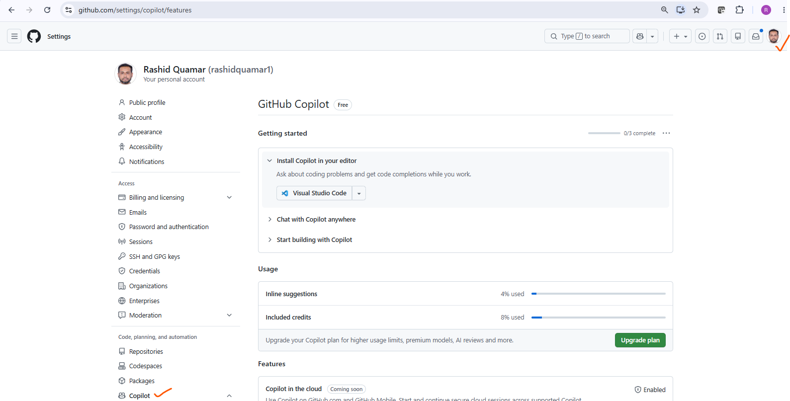
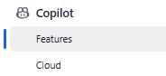
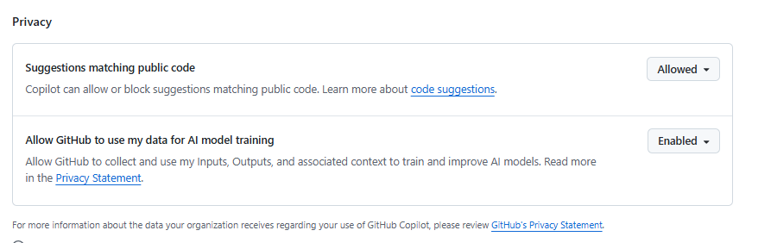

Manage content exclusions
The content exclusion feature in GitHub Copilot helps protect sensitive information by preventing the use of specific files, directories, or repositories to inform code-completion suggestions.

To implement content exclusion strategies, repository administrators and organization owners can use the following configurations:
  - Configure content exclusions for repositories
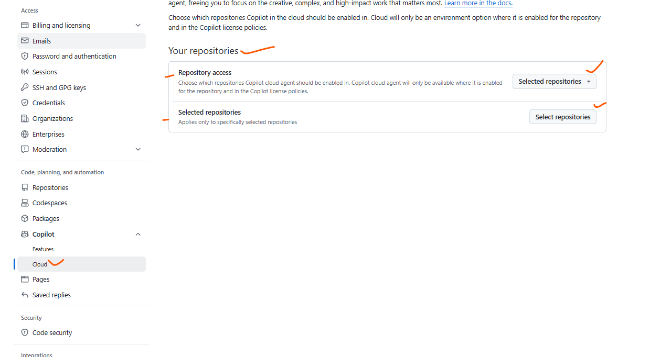

  - Configure content exclusions for organizations
- In the upper-right corner of GitHub, select your profile photo, and then select Your organizations.
- Next to the organization, select Settings.
- On the left sidebar, select Copilot > Content exclusion.
- Enter the details of files or repositories to exclude from Copilot suggestions.

Impact of content exclusion on code suggestions
Use content exclusions to configure GitHub Copilot to ignore certain files.
When we exclude content from GitHub Copilot:
- Code completion is no longer available in the affected files.
- The content in affected files won't inform code completion suggestions in other files.
- The content in affected files won't inform GitHub Copilot Chat responses.
When we exclude certain files or directories, GitHub Copilot won't use the content in those files to inform its suggestions. On the other side this reduction could potentially affect the accuracy and usefulness of the suggestions.

Limitations of content exclusions
IDE Limitation:
a). Copilot still “sees” excluded files if you open them.Even if a file or folder is excluded:
opening the file in the IDE,selecting text,copying/pasting code will still feed that content into Copilot’s context window.
Exclusion does NOT block context ingestion.
b). Exclusion does NOT block suggestions influenced by nearby code.Copilot uses:open buffers,recent edits,symbols in the workspace So even excluded paths can influence suggestions indirectly if related code is open.
c). Exclusion does NOT hide code from Copilot Chat If you:reference the file,attach it,paste content,ask a question about it Copilot Chat will still use it. Exclusion only prevents training, not usage.
d). Exclusion does NOT prevent accidental leakage in prompts
If a developer:copies sensitive code,pastes secrets,writes internal logic in a prompt Copilot will still process it. Exclusion does not sanitize user prompts.
e). Exclusion does NOT block autocomplete in all scenarios
Copilot may still: autocomplete variable names,infer patterns,generate similar structures based on open files, even if the folder is excluded.
f). Exclusion does NOT apply to GitHub Copilot Chat in the browser.The exclusion rules are IDE‑only.
GitHub.com chat uses repo context differently.
h). Exclusion does NOT prevent embeddings. If using: GitHub Copilot Enterprise,GitHub Spaces,Repo‑aware chat
Excluded paths may still be chunked for embeddings unless .copilotignore is used.
Semantic information : Copilot might still use semantic information from an excluded file if the IDE provides the information in a nonexcluded file
Policy scope: Content exclusion settings apply only to members of the organization in which we configure the content exclusion.
Anyone else who can access the specified files can still see code completion suggestions and Copilot Chat responses referencing the specified files.

Troubleshoot common problems with GitHub Copilot
1. Code suggestions are missing
- Content exclusion is blocking suggestions
- File type not supported
- Copilot extension outdated
- Network or firewall blocking Copilot
- File is too large
- You opened a file in an excluded path : Even if the repo is allowed, specific folders may be excluded by:.copilotignore
- IDE context window is overloaded

2. Content exclusions aren't working as expected
- Exclusions do NOT apply to open files
- Exclusions do NOT block suggestions in related files
- Exclusions take time to propagate : GitHub states:up to 30 minutes for org-level exclusions
- Repo-level exclusions do NOT override org-level policies
- Exclusions do NOT apply to GitHub.com Copilot Chat
- .copilotignore overrides UI exclusions
- Exclusions do NOT block embeddings in Copilot Enterprise

- Code suggestions are unsatisfactory
- Prompts are too vague
- The file is too large or too complex
- The language or framework is poorly represented
- Public code filter is enabled
- Content exclusions reduce context
- Copilot extension is outdated
- Network latency or proxy interference

Use cases for AI with GitHub Copilot

Boost developer productivity with AI
GitHub Copilot streamlines development workflows, allowing developers to focus on solving complex problems rather than getting bogged down in routine coding tasks

Areas where GitHub Copilot proves particularly beneficial
  - Accelerate learning new programming languages and frameworks
GitHub Copilot helps bridge the gap between learning and actual implementation through:
- Code suggestions
- Language support
- Documentation integration: By providing inline suggestions related to API usage and function parameters, GitHub Copilot reduces the need to constantly refer to external documentation.

- Minimizing context switching
Context switching is a significant productivity drain for developers and can disrupt your workflow and reduce focus
- In-editor assistance
- Quick references
- Code Completion

- Enhanced documentation writing
GitHub Copilot significantly improves the process of writing and maintaining code documentation
- Inline comments: Generates contextually relevant inline comments explaining complex code sections.
- Function descriptions: Automatically suggests function descriptions, including parameter explanations and return value details.
- README generation: Assists in creating project README files by suggesting structure and content based on the project's codebase.
- Documentation consistency: Helps maintain consistent documentation style across a project.

- Automating the boring stuff
- Boilerplate code generation
- Sample data creation
- Writing unit tests
- Code translation and refactoring

- Advanced boilerplate automation scenarios
- Generate complete database models, migration files, and ORM configurations based on simple entity descriptions.
- Create entire REST API endpoints with proper error handling, validation, and documentation comments.

- Generate configuration files for different environments (development, staging, production) with appropriate settings.
- Set up complete testing frameworks including mock data, fixtures, and helper functions for complex testing scenarios.

- Story-driven development automation
GitHub Copilot excels at transforming simple user stories and feature requirements directly into complete, production-ready implementations:

- Convert high-level feature descriptions into complete code structures with proper separation of concerns, including database models, API endpoints, and frontend components.

- Generate core functionality based on business rules described in plain language, automatically handling common patterns like validation, data transformation, and workflow logic.

- Create standardized patterns for connecting different parts of the application ecosystem, including authentication, logging, and external service integration.

- End-to-end automation: From a single user story, generate the complete feature stack including backend logic, database changes, API documentation, and basic frontend implementation.

- Automatically include error handling, input validation, logging, and basic security considerations as part of the initial implementation.

Accelerating pull request workflows
GitHub Copilot transforms the pull request process by generating changes that are review-ready and reducing the time from development to deployment
1. PR-ready code generation
When working on features or bug fixes, Copilot helps create comprehensive changes that minimize review cycles
- Generate full feature implementations with proper error handling, logging, and edge case coverage.
- Ensures new code follows established project conventions and architectural pattern
- Include inline comments, function documentation, and README updates as part of the initial code generation.
- Generate corresponding unit tests, integration tests, and example usage alongside new functionality
2. Intelligent code review assistance
Copilot can help prepare code for review and even assist during the review process itself
- Generate constructive, specific review comments that explain issues clearly and suggest concrete improvements with code examples.
- When reviewers request changes, Copilot can immediately generate multiple implementation alternatives, allowing authors to choose the best approach without extensive rewriting.
- Automatically improve code comments and documentation based on reviewer questions and feedback, ensuring clarity for future maintainers.
- Assist in resolving merge conflicts by understanding the intent of both code branches and suggesting optimal integration approaches.

- Collaborative development workflows
Copilot enhances team collaboration by ensuring consistency and quality across different developers'
- Help maintain consistent coding styles and patterns across team members.
- Generate code that follows team best practices, helping junior developers learn from senior patterns.
- When taking over someone else's work, Copilot can help understand existing code and continue development in the same style
- Assist in resolving complex merge conflicts by understanding the intent of both code branches.

Orchestrated AI workflows
GitHub Copilot can work as part of orchestrated workflows where multiple AI capabilities complement each other:
  - Multi-agent development patterns
Consider a workflow where different AI agents handle distinct aspects of feature development:
  - Draft agent: Copilot generates initial code implementations based on feature requirements
  - Review agent: A secondary AI reviews the draft for code quality, security issues, and adherence to project standards
  - Documentation agent: Automatically generates or updates documentation based on the code changes
  - Test agent: Creates comprehensive test suites for the new functionality

  - Advanced reasoning capabilities
For complex development scenarios, GitHub Copilot offers premium reasoning modes that provide deeper analysis and more sophisticated code generation:
  - Automated story completion workflows
GitHub Copilot can transform user stories and requirements into complete, deployable features through automated workflows:
- Requirements parsing: Analyze user stories and acceptance criteria to generate implementation plans
- Feature scaffolding: Create complete feature structures including controllers, services, models, and tests
- Integration setup: Generate the necessary code to integrate new features with existing system components
- Quality assurance automation: Include comprehensive error handling, logging, and monitoring for new features

  - Personalized code completion
GitHub Copilot adapts to individual coding styles and project contexts, providing increasingly relevant suggestions over time and improving code efficiency
- Contextual understanding: GitHub Copilot analyzes the development environment and project structure to offer more accurate and relevant code completions.
- Learning from patterns: As developers work on a project, GitHub Copilot learns from their coding patterns and preferences, tailoring suggestions accordingly.

AI in the Software Development Lifecycle (SDLC)

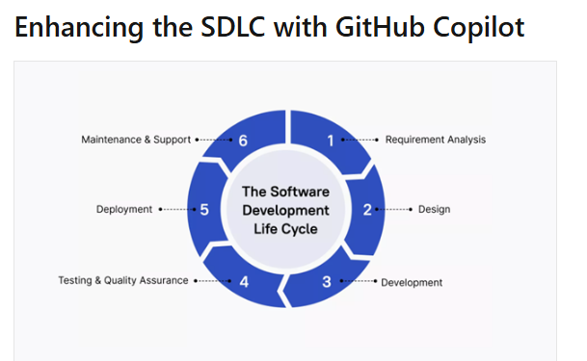

Requirement analysis
GitHub Copilot doesn't directly gather requirements, it can assist in translating requirements into initial code structures
- Rapid prototyping
- User story implementation
- API design
Design & development
- Boilerplate code generation
- Design pattern implementation
- Code optimization
- Cross-language translation
Testing & quality assurance
- Unit test creation
- Test data generation
- Edge case identification
- Assertion suggestions: Propose appropriate assertions based on the expected behavior of the code being tested

Automated testing workflows
- Test suite architecture
- Test automation pipelines
- Quality gates
- Performance testing

Deployment
- Configuration file generation
- Deployment script assistance
- Documentation updates

Maintenance & support
- Bug fix suggestions
- Code refactoring
- Documentation updates
- Legacy code understanding

Limitation and Impacts of GitHub Copilot
GitHub Copilot offers significant benefits, it's crucial to understand its limitations and accurately measure its impact on development processes
  - Code quality and correctness
- Potential for errors: GitHub Copilot can sometimes suggest code that contains bugs or doesn't fully meet requirements.
- Security concerns: Generated code may not always adhere to best security practices, requiring careful review.
- Context misinterpretation: GitHub Copilot might misunderstand the broader context, leading to inappropriate suggestions.

  - Language and framework specificity
- Varying performance: GitHub Copilot's effectiveness can vary across different programming languages and frameworks.
- Niche technologies: For less common or newer technologies, suggestions may be less accurate or relevant.

  - Dependency on training data
- Bias in suggestions: GitHub Copilot's suggestions reflect patterns in its training data, which may include biases or outdated practices.
- Copyright concerns: There's ongoing debate about the copyright implications of code generated from trained models.
  - Complex problem solving
- Limitation in high-level design: GitHub Copilot excels at code-level tasks but may not grasp complex architectural decisions.
- Creativity constraints: While helpful, GitHub Copilot cannot replace human creativity in solving novel problems.

Measure productivity gains
Understanding the productivity gains provided by GitHub Copilot is essential to maximize its benefits

Following ways to measure and analyze how GitHub Copilot influences development workflow:

  - REST API for GitHub Copilot usage metrics

GitHub provides a REST API to access GitHub Copilot usage metrics for enterprise members, teams, and organization members. This helps us to know the daily usage of github copilot in an enterprise

GitHub Copilot usage for enterprise members
Endpoint: GET /enterprises/{enterprise}/GitHub Copilot/usage

GitHub Copilot usage for an enterprise team
Endpoint: GET /enterprises/{enterprise}/team/{team_slug}/GitHub Copilot/usage

GitHub Copilot usage for organization members
Endpoint: GET /orgs/{org}/GitHub Copilot/usage

Implementing a measurement framework
To systematically assess GitHub Copilot’s impact
- Evaluation: During the initial phase of adopting GitHub Copilot, focus on leading indicators such as developer satisfaction and task completion rates. Use the API to collect metrics like Average Daily Active Users, Total Acceptance Rate, and Lines of Code Accepted.
- Adoption: As GitHub Copilot becomes more integrated into the team’s workflow, continue to monitor productivity metrics and enablement indicators. The API can provide insights into user engagement and identify areas where further training may be needed.

- Optimization: Once GitHub Copilot is fully adopted, use the REST API for GitHub Copilot usage metrics to fine-tune its impact on broader organizational goals, such as reducing time-to-market or improving code quality across the team.

- Sustained efficiency: Continuously evaluate GitHub Copilot’s effectiveness as the organization evolves. The API allows for ongoing monitoring and adjustment to ensure long-term productivity gains.

  - GitHub Copilot Developer Survey

The GitHub Copilot Developer Survey is a valuable tool designed to gather insights from teams, helping understand how GitHub Copilot is being used, its benefits, and any challenges developers face.
This survey is divided into two formats: short-form and long-form, each serving different purposes throughout the GitHub Copilot evaluation and adoption stages

Survey cadence and timing
When deploying the GitHub Copilot Developer Survey, it's important to establish a regular cadence to avoid survey fatigue while still gathering meaningful data.
- Short-form survey: Can be conducted every two weeks if frequent feedback is needed, especially when coupled with other feedback channels like online or in-person discussions.
- Long-form survey: Recommended to be conducted no more than once every four weeks, particularly at the end of the evaluation and adoption stages, to capture comprehensive feedback.

Structuring the survey
The survey questions should be tailored to fit organization’s specific needs, ensuring that the data collected is relevant and actionable. Here’s how to structure both the short-form and long-form surveys:
- Short-form survey: Focuses on immediate feedback, capturing developers' overall satisfaction with GitHub Copilot, specific challenges faced, and time saved or wasted.
  - Example questions:
    - "How would you feel if you could no longer use GitHub Copilot?"
    - "When using GitHub Copilot, I enjoy coding more / write better quality code / complete tasks faster."
    - "What challenges have you encountered in using GitHub Copilot since your last survey?"
- Long-form survey: Offers a deeper analysis of GitHub Copilot’s impact, capturing detailed insights into its usage and benefits, and how it affects team dynamics.
  - Example questions:
    - "I use GitHub Copilot to code in a familiar language / explore a new language / write repetitive code."
    - "When using GitHub Copilot, my team provides better code reviews / merges code to production faster."
    - "What challenges have you encountered in using GitHub Copilot since your last survey?"
Analyzing survey results
Once the surveys are completed, it’s important to analyze the results systematically:
- Privacy considerations: Ensure that survey responses are anonymized and cannot be traced back to individual developers, meeting privacy obligations.
- Data tracking: Collate the survey responses into existing Business Intelligence (BI) tools or spreadsheets for ease of analysis. Over time, track the results to identify trends and make informed decisions about GitHub Copilot’s implementation

Continuous improvement
Use the insights gathered from the surveys to make informed decisions about GitHub Copilot's deployment in organization. Focus on addressing the challenges identified, leveraging the benefits reported by developers, and adjusting the tool’s use to maximize productivity.
The GitHub Copilot Developer Survey is a critical component in understanding and enhancing the use of GitHub Copilot within team
Leveraging the REST API and survey for GitHub Copilot usage metrics, we can concrete insights into how GitHub Copilot influences

